**Mitosis Quiz**

|  |  |
| --- | --- |
| Name: Jayda Olds | Date: 4/27/2020 |

1. Label the following diagram with the phase of mitosis, (a) through (e), or the type of cell structure, (f) through (h), seen during mitosis.

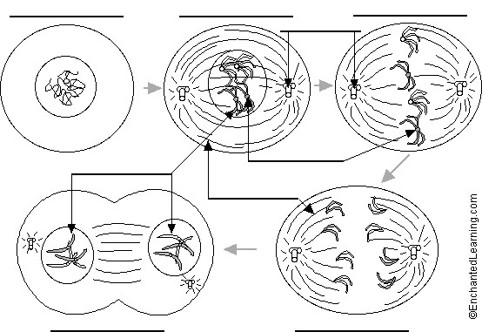

1. During which stage of a cell’s cycle do the replicated chromosomes thicken and become visible? ______________________

1. During which stage of a cell's cycle do the replicated chromosomes line up on the equator of the cell? ______________________

1. During which stage of a cell's cycle do the chromosomes replicate? ____________

1. The drawing below has been made from a photograph showing a cell undergoing mitosis. Based on the drawing, in what stage of mitosis must the cell have been in?

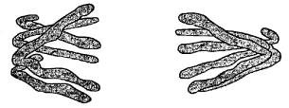

______________________

1. The drawings A-E show stages of mitosis in a plant cell.

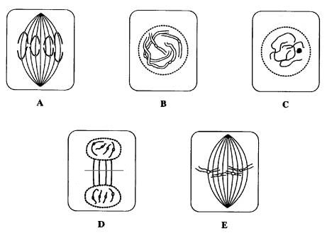

* 1. Which of the drawings A -E shows
     1. interphase ________ (**DNA** is replicated)
     2. prophase ________ (**chromosomes** – 2 **sister chromatids** – shorten)
     3. metaphase ________ (**sister chromatids** line up)
     4. anaphase ________ (**sister chromatids** separate)
     5. telophase ________ (new nucleus forms at each end)
     6. cytokinesis ________ (cell contents divided between 2 **daughter cells**)
  2. Give two processes which occur during interphase and which are necessary for mitosis to take place.

____________________ of the cell and ____________________ of the DNA

1. This drawings shows various stages of mitosis in a fast growing onion root tip.

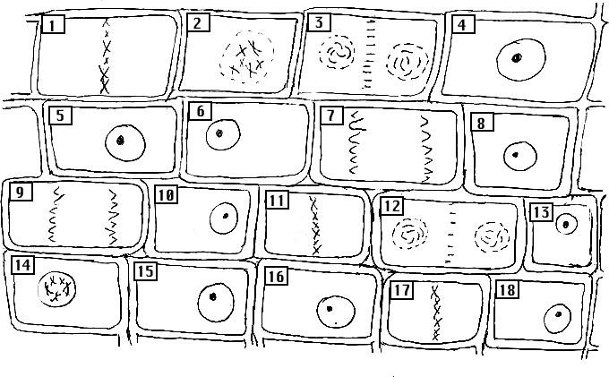

Identify the cells (by number) which are in the following stages of mitosis:

|  |  |
| --- | --- |
| interphase | _____________ |
| prophase | _____________ |
| metaphase | _____________ |
| anaphase | _____________ |
| telophase | _____________ |

1. Using colored pens or pencils, show how 2 chromosomes are passed from parent cell to two daughter cells.

